
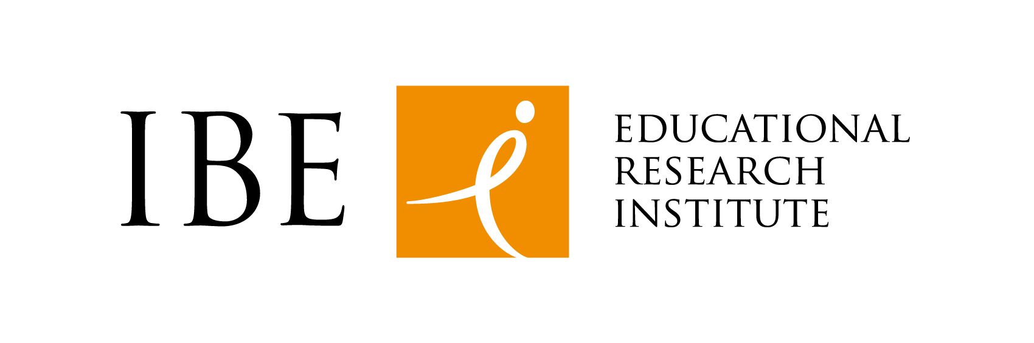
Warszawa, 27.09.2019

Call for Papers

“EDUKACJA” quarterly
announces the call for articles
"BUILDING A CULTURE OF RESEARCH INTEGRITY:
PROBLEMS, CHALLENGES, GOOD PRACTICES "

Dear Authors,
We encourage you to submit articles for publication in our journal - in a special English-language thematic issue of the 'Education' quarterly, which will deal with the issues of Research Integrity and Research Ethics. The work on the number is related to the implementation of the project "Rotatory role-playing and role-models to enhance the research integrity culture - Path2Integrity" under the Horizon 2020 program (https://www.path2integrity.eu/).

In the face of rapid changes in the European research environment, it is becoming increasingly important to highlight the benefits of research integrity and research ethics. Strengthening the culture of scientific reliability and improving the trust of civil society in research are the main objectives of teaching integrity and research ethics.

We invite: academics, researchers of research integrity and research culture, members of international consortia implementing EU projects as well as teachers and trainers of research integrity and research ethics who would like to share their didactic experience to submit their texts for the publication of this special issue to strengthen research integrity.

We are waiting for articles dealing with following topics:

- teaching research integrity and research ethics in high schools and universities;
- formation of trainers and teachers dealing with research integrity and research ethics in their practice (in didactics);
- perception of the role of scientists, research integrity and ethical authorities in research;
- good and bad practices in the area of ​​research integrity;
- respecting, implementing and practical functioning of national and international regulations regarding the principles of ethics and integrity in science;
- implementing solutions that promote and strengthen the culture of research integrity in local and international academic environments.

Articles in English with a volume of 30-50 thousand characters with spaces (+ references cited) please send by November 25, 2019; at: redakcja@ibe.edu.pl.

The journal is published in accordance with the open access principles (CC BY license), which means that its users can read, download, copy, distribute, print, search or link a source of full texts of articles published on the EDUKACJA website without the prior permission of the publisher or author. Detailed information on publishing practices can be found in the "For authors" tab.The Editorial Board does not charge for submission, preparing, downloading or sharing articles.

Detailed information on publishing practices can be found at:
http://www.edukacja.ibe.edu.pl/en/for-authors/guidelines-for-authors

Editors of the quarterly 'Education'

Path2Integrity team
Dr Agnieszka Dwojak-Matras
Dr Katarzyna Kalinowska
Dr Agnieszka Koterwas

